DATA FLOW DIAGRAM AND USER STORIES
Date | 27 JAN 2026
Team Id | LTVIP2026TMIDS81631
Project name | BOOK NEST: WHERE STORIES NESTLE
marks

DATA FLOW DIAGRAM:
Data Entities for DFD
- User (UserID, Name, Email, Password, Address)
- Book (BookID, Title, Author, Price, ISBN, Stock)
- Cart (CartID, UserID, BookID, Quantity)
- Order (OrderID, UserID, OrderDate, Status, TotalAmount)
- Payment (PaymentID, OrderID, Amount, PaymentMethod, Status)
- Admin (AdminID, Username, Password)
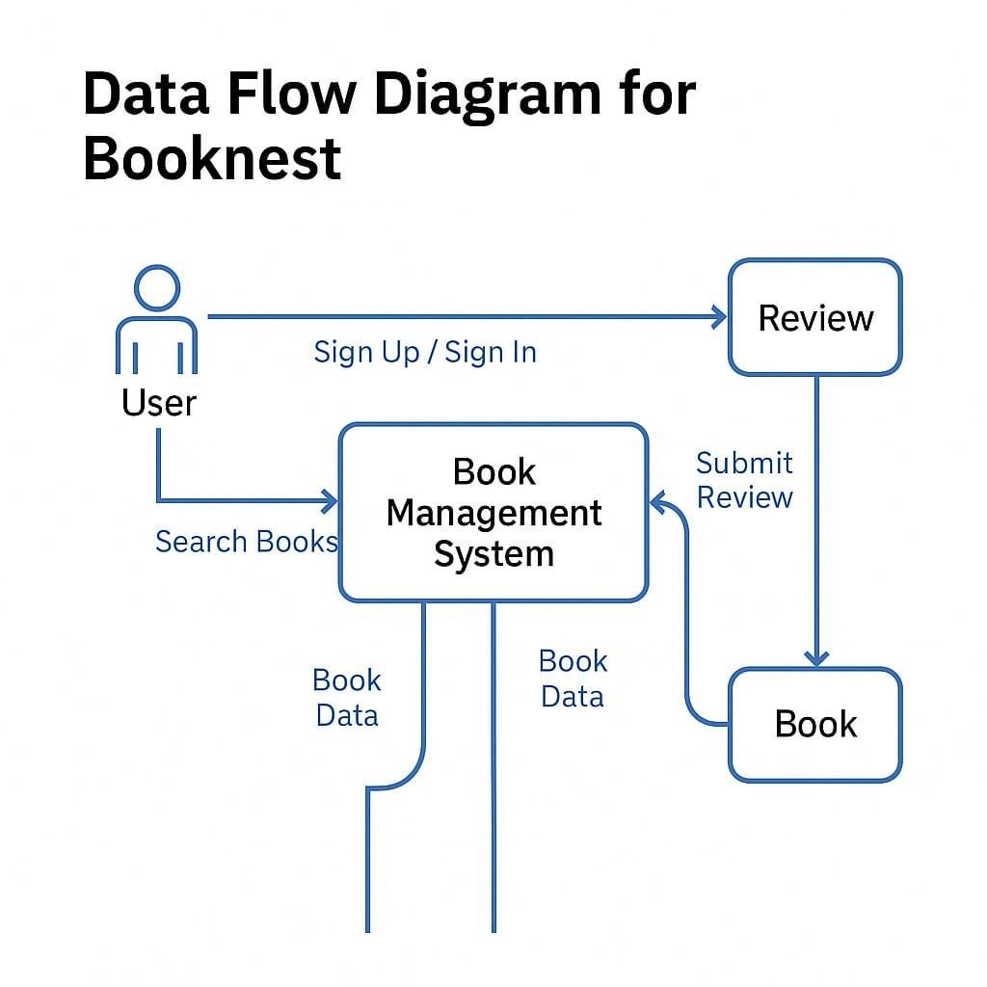

USER STORIES:
User Stories (Agile Format) As a User:

1. Registration/Login
o As a user, I want to register and log in so that I can buy books from the store.

2. Browse Books
o As a user, I want to browse and search for books so that I can find titles I'm interested in.

3. Add to Cart
o As a user, I want to add books to my cart so that I can purchase them together.
4. Checkout o As a user, I want to securely make payments and track my orders.

5. Order History
o As a user, I want to view past orders so I can reorder or review them.
As an Admin:

1. Manage Catalog
o As an admin, I want to add or remove books so that the catalog stays current.

2. View Orders
o As an admin, I want to view order data so I can analyze performance.

3. Inventory Management
o As an admin, I want to manage stock levels to prevent out-of-stock scenarios.

